**Q. From the figure and the data given below, using Bayes Rule and calculate:**

|  |  |  |  |
| --- | --- | --- | --- |
|  | | **Cough** | |
| **Pneumonia** | **Smoking** | **True** | **False** |
| **True** | **Yes** | 0.95 | 0.05 |
| **True** | **No** | 0.8 | 0.2 |
| **False** | **Yes** | 0.6 | 0.4 |
| **False** | **No** | 0.05 | 0.95 |

|  |  |  |  |  |  |
| --- | --- | --- | --- | --- | --- |
| **Pneumonia** |  |  | **Smoking** |  |  |
| **True** | 0.1 |  |  | **Yes** | 0.2 |
| **False** | 0.9 |  |  | **No** | 0.8 |

|  |  |  |
| --- | --- | --- |
|  | **Temperature** | |
| **Pneumonia** | **Yes** | **No** |
| **Yes** | 0.9 | 0.1 |
| **No** | 0.2 | 0.8 |

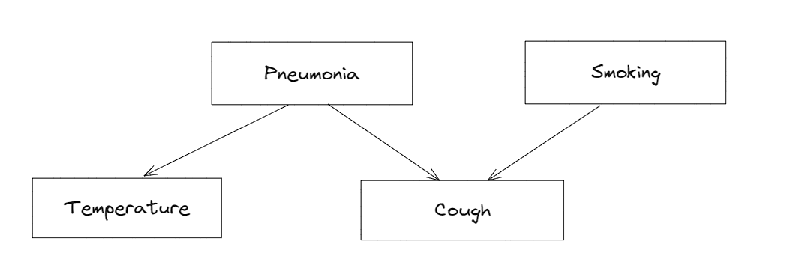

**Solution:**

**Let c, be the event for the cough.** *(Here, c represents to not cough)*

**Let p, be the event for pneumonia.** *(Here, p represents to not pneumonia)*

**Let s, be the event for smoking.** *(Here, s represents to not smoking)*

i. P (c/ (p & s)) = 0.95

ii. P (c/ (p & s)) = 0.05

iii. P (c/ (p & s)) = 0.6 iv. P (c/ (p & s)) = 0.8

P (c) = [P (c/p ∩ s)] * P(p) * P(s) + [P (c/p ∩ s)] * P(p) * P(s) + [P (c/p ∩ s)] * P(p) * P(s) + [P (c/p ∩ s)] * P(p) * P(s)

= 0.95 * 0.1 * 0.2 + 0.6 * 0.9 * 0.2 + 0.8 * 0.1 * 0.8 + 0.05 * 0.9 * 0.8

= 0.019 + 0.108 + 0.064 + 0.036

= 0.227

P(c/s) = [P (c/p ∩ s)] * P(p) + [P (c/p ∩ s)] * P(p)

= 0.95* 0.1 + 0.6*0.9

= 0.095 + 0.54

= 0.635

P(s/c) = [ P(c/s) * P(s)] / P(c)

= [ 0.635*0.2] / 0.227

= 0.55

P(c/s) = [P (c/p ∩ s)] * P(p) * 1 + [P (c/p ∩ s)] * P(p) * 1

= 0.8 * 0.1 + 0.05 * 0.9

= 0.08 * 0.045

= 0.125